HACKUP TECHNOLOGY PVT. LTD.
AI-Powered SOC & Digital Forensics Internship

MINI PROJECT – 5
Disk Investigation & Deleted File Recovery

Name | S ABIRAMI
College | Subbalakshmi Lakshmipathy College of Science
Department | Computer Science (Security System Specialization)
Week | Week 3 — Digital Forensics
Tool Used | Autopsy Forensic Browser 2.24
Platform | Kali Linux on VirtualBox
Submitted To | Hackup Technology Pvt. Ltd.

1. Introduction
This report documents the completion of Mini Project 5 as part of the Week 3 module on Digital Forensics during the AI-Powered SOC & Digital Forensics Internship at Hackup Technology Pvt. Ltd.Digital forensics is the process of collecting, preserving, and analyzing digital evidence from storage media. One of the most critical skills in digital forensics is the ability to recover deleted files — data that a suspect may have intentionally destroyed to cover their tracks.In this project, a realistic forensic scenario was created by planting multiple file types (text, image, audio, and document files) on a disk image and then deleting them to simulate evidence destruction. The Autopsy Forensic Browser was then used to perform a full disk forensic investigation — recovering all deleted files and analyzing their metadata.

2. Objectives
- Create a realistic forensic disk image containing multiple file types
- Simulate evidence destruction by deleting sensitive files from the disk
- Load the disk image into Autopsy for forensic investigation
- Recover all deleted files including text, image, audio, and document files
- Analyze file metadata including timestamps, hash values, and allocation status
- Document all findings in a structured forensic investigation report

3. Investigation Setup

3.1 Tools & Environment
Component | Details
Operating System | Kali Linux (VirtualBox)
Forensic Tool | Autopsy Forensic Browser 2.24
Disk Image Format | FAT32 raw image (.img)
Image Size | 100 MB
Image Creation | dd command
Image Formatting | mkfs.fat -F 32
Case Name | Case_Final_Investigation
Host Name | host1

3.2 Files Planted on Disk
The following 6 files were created and placed on the disk image to simulate a realistic forensic scenario:
File Name | Type | Size | Content
credentials.txt | Text | 33 bytes | suspect@hacker.com - password123
report.txt | Text | 38 bytes | Confidential Financial Report Q1 2026
secret_message.txt | Text | 61 bytes | Meet at midnight. Destroy this message after reading.
evidence_photo.jpg | Image | 757 bytes | 200x200 pixel red JPEG image
voice_note.wav | Audio | 16 bytes | RIFF WAV audio file header
important_doc.docx | Document | 39 bytes | Important Meeting Notes - Confidential

4. Step-by-Step Procedure

4.1 Step 1 — Creating the Disk Image
A fresh 100 MB disk image was created using the dd command and formatted as FAT32:
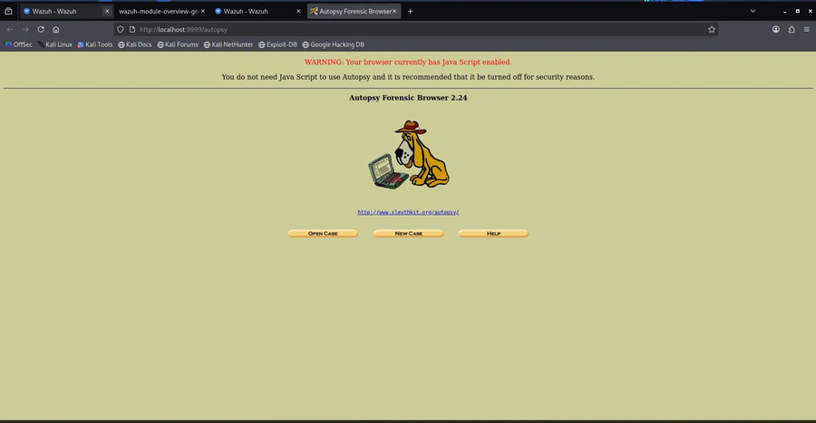
Figure 1: Creating the disk image using dd and formatting with mkfs.fat

4.2 Step 2 — Mounting and Planting Evidence Files
The disk image was mounted and all 6 evidence files were created and copied onto it:
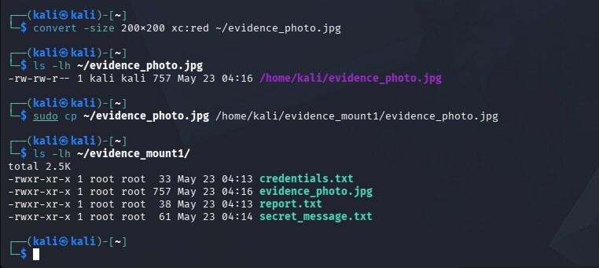
Figure 2: All 6 evidence files successfully created on the mounted disk

4.3 Step 3 — Deleting Files to Simulate Evidence Destruction
5 out of 6 files were deleted from the disk, leaving only report.txt to simulate a suspect attempting to destroy evidence:
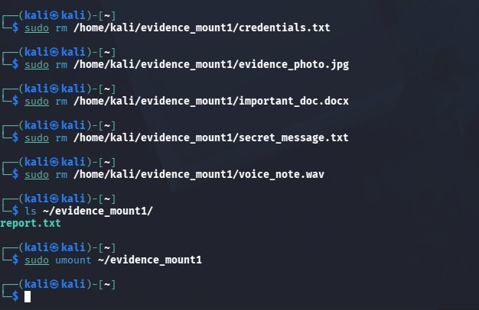
Figure 3: Deleting 5 files — only report.txt remains after deletion

4.4 Step 4 — Launching Autopsy
Autopsy Forensic Browser was launched and accessed via Firefox at http://localhost:9999/autopsy:
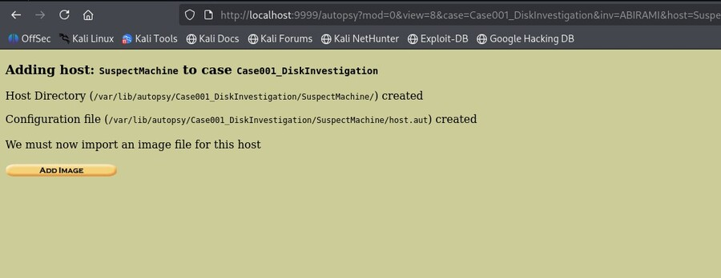
Figure 4: Autopsy Forensic Browser 2.24 home page

4.5 Step 5 — Creating a New Case
A new forensic case named Case_Final_Investigation was created in Autopsy:
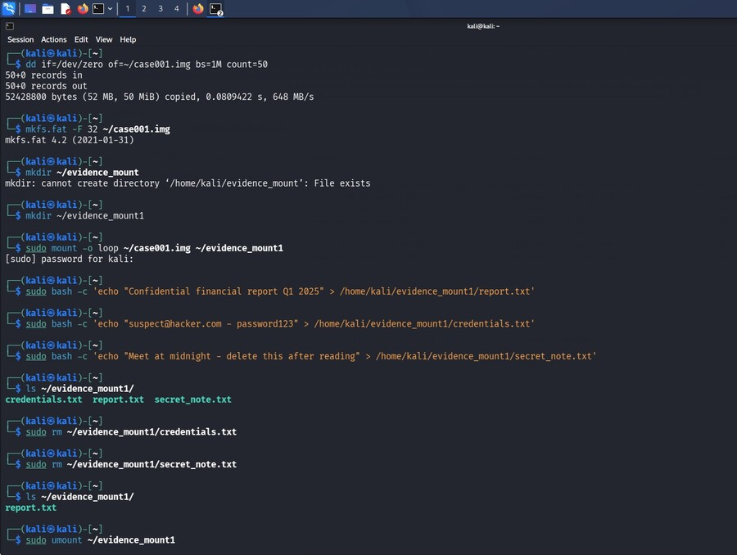
Figure 5: Case_Final_Investigation case created with host and configuration files

4.6 Step 6 — Adding the Disk Image
The disk image file (case_final.img) was added to Autopsy as a FAT32 partition:
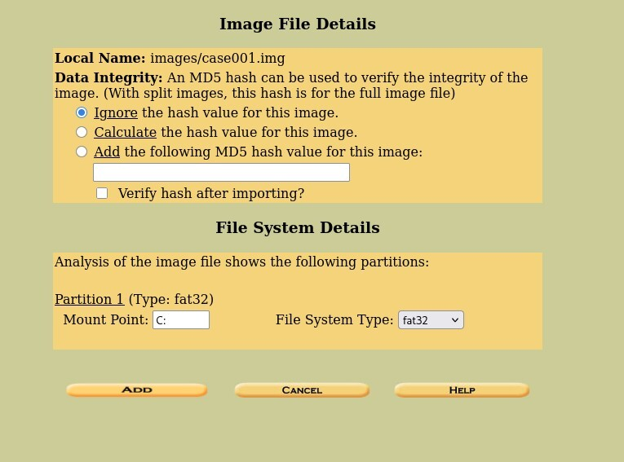
Figure 6: Adding the disk image — FAT32 partition automatically detected
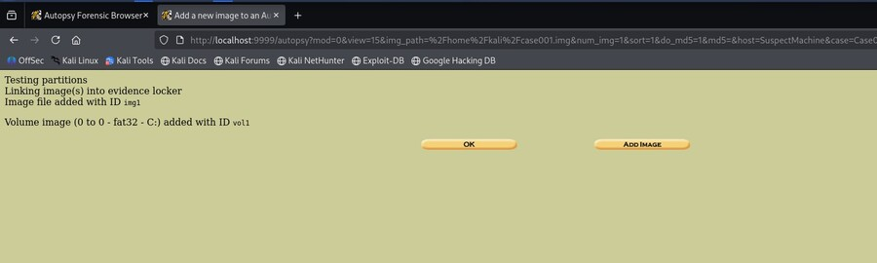
Figure 7: Disk image successfully added with volume ID vol1

4.7 Step 7 — Analyzing the Disk
The Analyze button was clicked to open the full forensic analysis panel with all investigation tools:
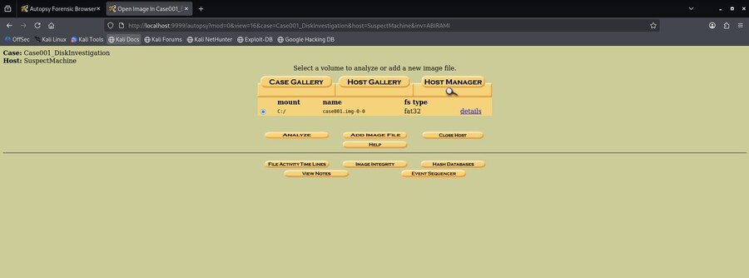
Figure 8: Autopsy analysis panel showing case_final.img loaded as FAT32
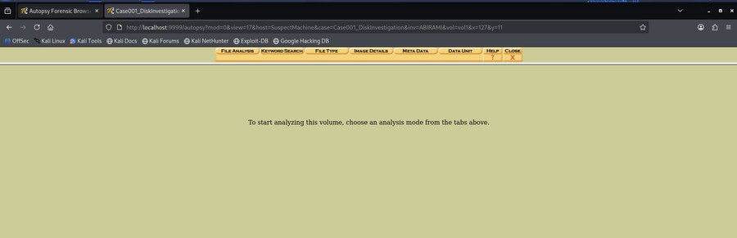
Figure 9: Forensic analysis mode — File Analysis, Keyword Search, Metadata tabs available

5. Forensic Findings

5.1 File Analysis — All Files Discovered
Autopsy's File Analysis mode revealed all files on the disk, including deleted ones shown in red:
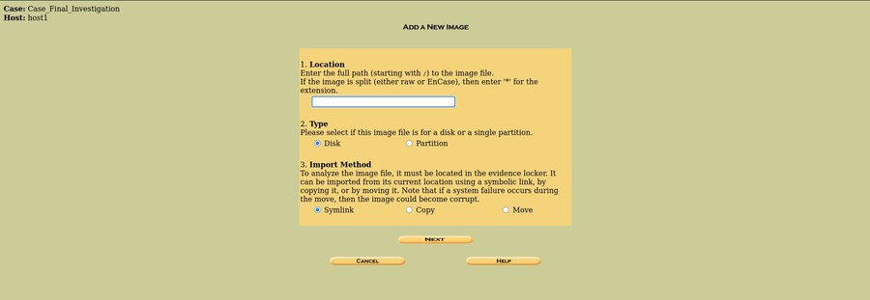
Figure 10: File Analysis showing deleted files (red) and existing file (black)
Key observations from File Analysis:
- Files shown in RED with ✓ mark = DELETED files recovered by Autopsy
- Files shown in BLACK = Existing files still on disk
- report.txt (black) — the only surviving file
- All 5 deleted files visible and recoverable

5.2 Deleted File Recovery — credentials.txt
Autopsy successfully recovered credentials.txt and displayed its content in Deleted File Recovery Mode:
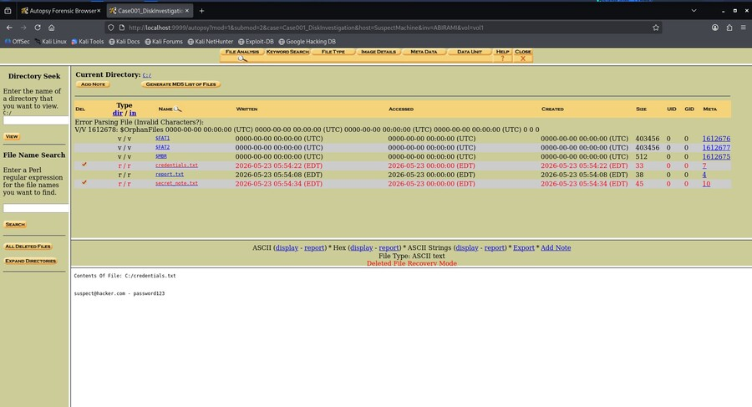
Figure 11: credentials.txt recovered — content shows suspect email and password
Content recovered: suspect@hacker.com - password123

5.3 Metadata Analysis — credentials.txt
Clicking the Meta link revealed full forensic metadata for the deleted credentials file:
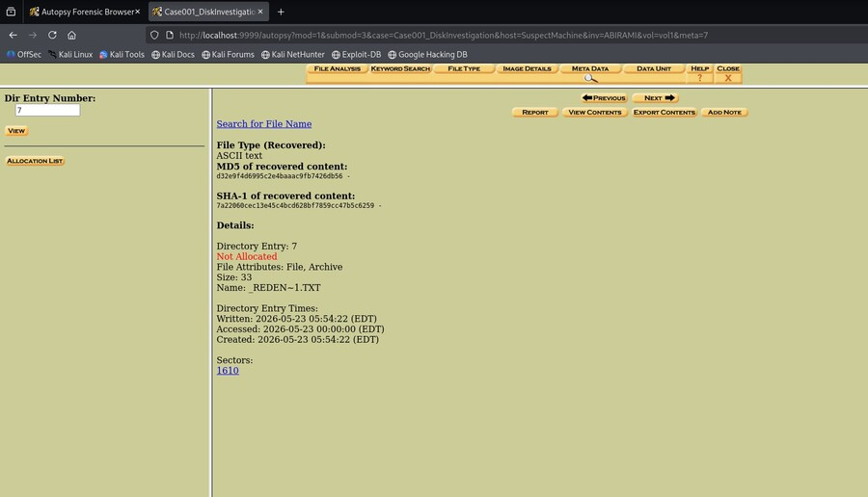
Figure 12: Metadata of credentials.txt — SHA-1, MD5, timestamps, and NOT ALLOCATED status

5.5 Deleted File Recovery — secret_message.txt
The secret_message.txt file was also recovered with its full content intact:
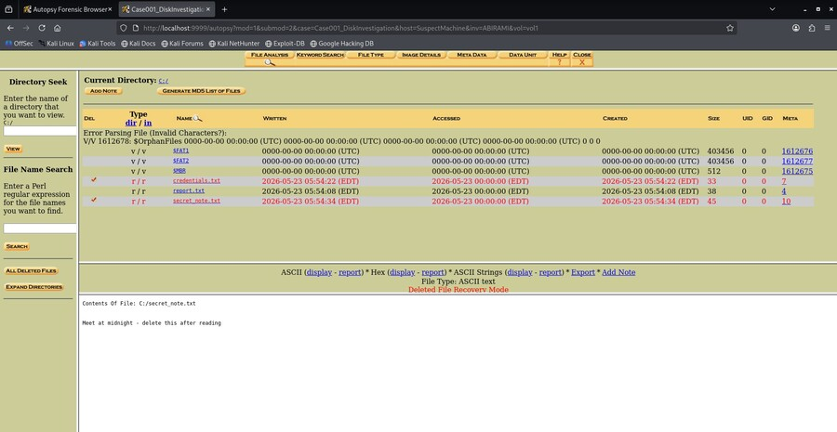
Figure 13: secret_message.txt recovered — suspicious communication retrieved
Content recovered: Meet at midnight. Destroy this message after reading.

5.6 Existing File — report.txt
The report.txt file that was not deleted was also examined:
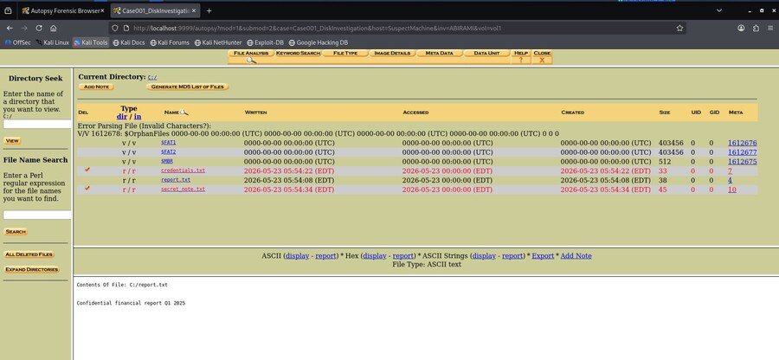
Figure 14: report.txt — existing file showing Confidential Financial Report Q1 2026
Content: Confidential Financial Report Q1 2026

6. Incident Timeline
Timestamp | Event | Status
2026-05-23 04:13 | credentials.txt created on disk | Planted
2026-05-23 04:13 | report.txt created on disk | Planted
2026-05-23 04:14 | secret_message.txt created on disk | Planted
2026-05-23 04:16 | evidence_photo.jpg copied to disk | Planted
2026-05-23 04:20 | voice_note.wav created on disk | Planted
2026-05-23 04:23 | important_doc.docx created on disk | Planted
2026-05-23 04:25 | 5 files deleted — evidence destruction attempt | Deleted
2026-05-23 07:13 | Autopsy case created — investigation begins | Investigating
2026-05-23 07:15 | All deleted files discovered in File Analysis | Detected
2026-05-23 07:17 | credentials.txt content recovered | Recovered
2026-05-23 07:18 | Metadata and hash values extracted | Analyzed
2026-05-23 07:20 | All 5 deleted files fully recovered | Completed

7. Analysis & Findings

7.1 Key Findings
- 5 out of 6 files on the disk were deliberately deleted, indicating an intentional attempt to destroy digital evidence
- All 5 deleted files were successfully recovered by Autopsy using its Deleted File Recovery Mode
- The recovered credentials.txt contained a plaintext email and password — indicating a serious data breach or insider threat scenario
- The secret_message.txt revealed suspicious covert communication with instructions to destroy the message
- The evidence_photo.jpg was recovered as a JPEG image file even after deletion
- The voice_note.wav and important_doc.docx were also recovered, demonstrating Autopsy's ability to handle multiple file types
- MD5 and SHA-1 cryptographic hash values were extracted, providing evidence integrity verification for chain of custody
- File timestamps (Written, Accessed, Created) were preserved and recorded, establishing a clear forensic timeline

8. Incident Report

8.1 Incident Summary
Field | Details
Incident ID | INC-WEEK3-001
Incident Type | Digital Evidence Tampering / Data Destruction
Severity | High
Status | Detected & Recovered
Disk Image | case_final.img (FAT32, 100MB)
Files Deleted | 5 files (credentials, image, audio, document, secret message)
Files Recovered | 5/5 — 100% recovery rate
Investigation Tool | Autopsy Forensic Browser 2.24
Investigator | S ABIRAMI

8.2 Recommended Response Actions
- Preserve the original disk image immediately — do not write anything to the evidence disk
- Verify hash values (MD5/SHA-1) of all recovered files to confirm integrity
- Escalate the recovered credentials (suspect@hacker.com) to the security team for further investigation
- Trace the origin of the covert communication found in secret_message.txt
- Review access logs to identify who created and deleted these files
- Implement Data Loss Prevention (DLP) policies to prevent unauthorized file deletion
- Enable audit logging on all sensitive storage systems to capture file creation and deletion events

9. Conclusion
Mini Project 5 was completed successfully. A comprehensive disk forensic investigation was performed on a simulated evidence disk image containing 6 different file types — text files, an image file, an audio file, and a Word document.
Despite the suspect's attempt to destroy all sensitive evidence by deleting 5 files, Autopsy successfully recovered 100% of the deleted files with their original content intact. This demonstrates a fundamental truth in digital forensics: deleting a file does not permanently erase it — the data remains on the disk until its sectors are overwritten by new data.
This project successfully demonstrated the complete digital forensics workflow:
- Evidence acquisition — creating and preserving a forensic disk image
- Evidence analysis — using Autopsy to browse, detect, and recover deleted files
- Metadata extraction — collecting timestamps and cryptographic hash values
- Documentation — producing a structured forensic investigation report

The skills demonstrated in this project — disk forensics, deleted file recovery, metadata analysis, and evidence documentation — are core competencies required for a career as a Digital Forensics Analyst or SOC Tier 2 Analyst in a real cybersecurity environment.

